Exercise 22.2.1

Show the d and π values that result from running breadth-first search on the directed graph of Figure 22.2(a), using vertex 3 as the source.

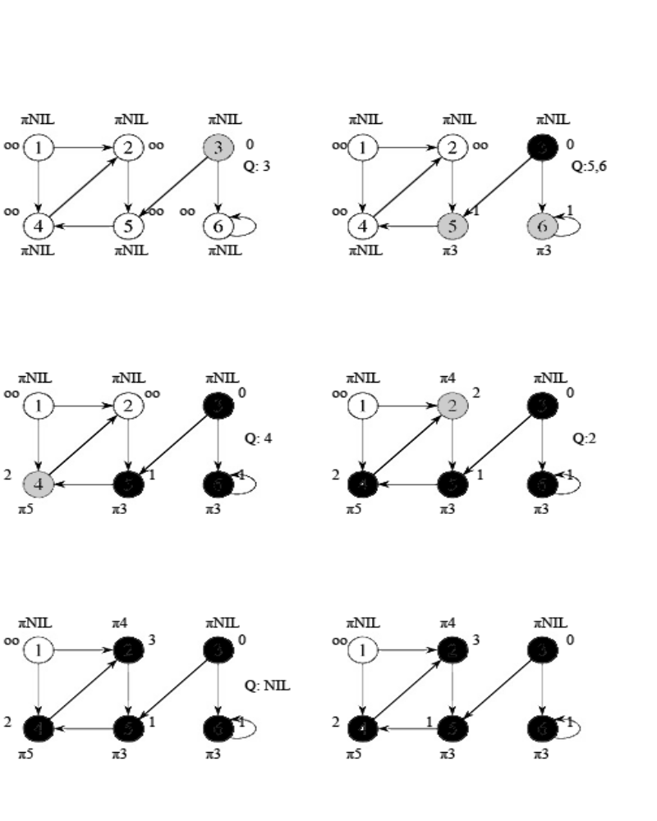
Exercise 22.2.2
Show the d and π values that result from running breadth-first search on the undirected graph of Figure 22.3, using vertex u as the source.
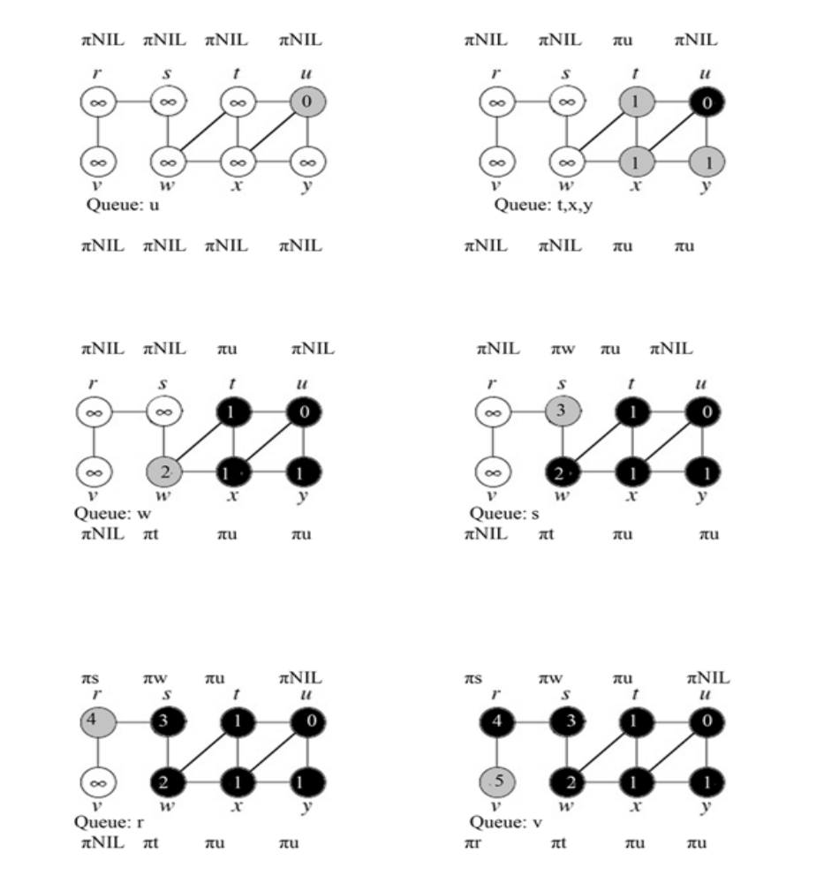
Exercises 22.3-1

Make a 3-by-3 chart with row and column labels WHITE, GRAY, and BLACK. In each cell (i, j), indicate whether, at any point during a depth-first search of a directed graph, there can be an edge from a vertex of color i to a vertex of color j. For each possible edge, indicate what edge types it can be. Make a second such chart for depth-first search of an undirected graph.

Let i be the row and j be the column

Directed Graph | WHITE | GRAY | BLACK
WHITE | Back, Cross, Forward, Tree | Back, Cross | Cross
GREY | Forward, Tree | Back, Forward, Tree | Forward, Cross, Tree
BLACK |  | Black | Forward, Back, Cross, Tree

Theorem: In a depth-first search of an undirected graph G, every edge of G is either a tree edge or a back edge.

Undirected Graph | WHITE | GRAY | BLACK
WHITE | Back | Back
GREY | Back | Back | Back
BLACK |  | Back | Back

Exercise 22.3.2

Show how depth-first search works on the graph of Figure 22.6. Assume that the for loop of lines 5-7 of the DFS procedure considers the vertices in alphabetical order, and assume that each adjacency list is ordered alphabetically. Show the discovery and finishing times for each vertex, and show the classification of each edge.

